Bug Screenshots
- TC_002-Username accepts less than 6 characters
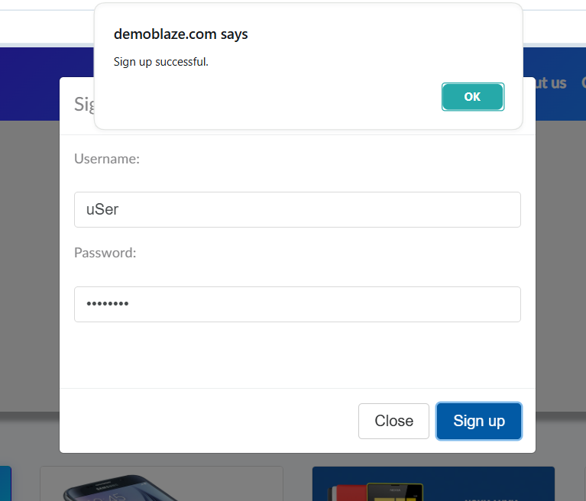
Bug_001_Username.png
- TC_003-Password accepts less than 6 characters
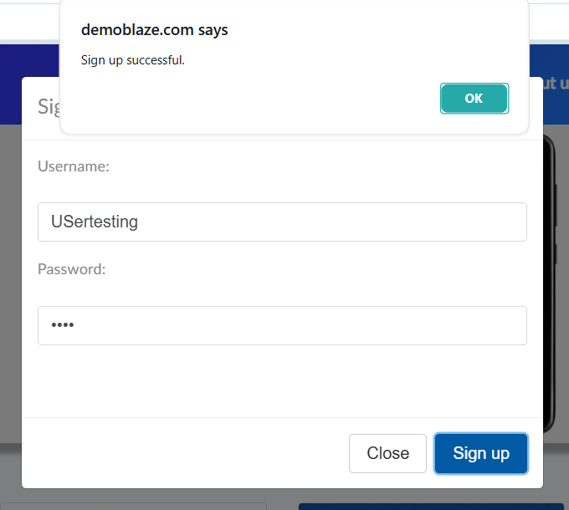
Bug_002_Password.png

- TC_011-No password complexity rules enforced
Bug_003_PasswordComplexity.png
- TC_012-Missing "Confirm Password" field
Bug_004_ConfirmPassword.png

- TC_022-"Forgot Password" link is missing
Bug_005_ForgotPassword.png
- TC_040-No "Out of Stock" banner for unavailable items
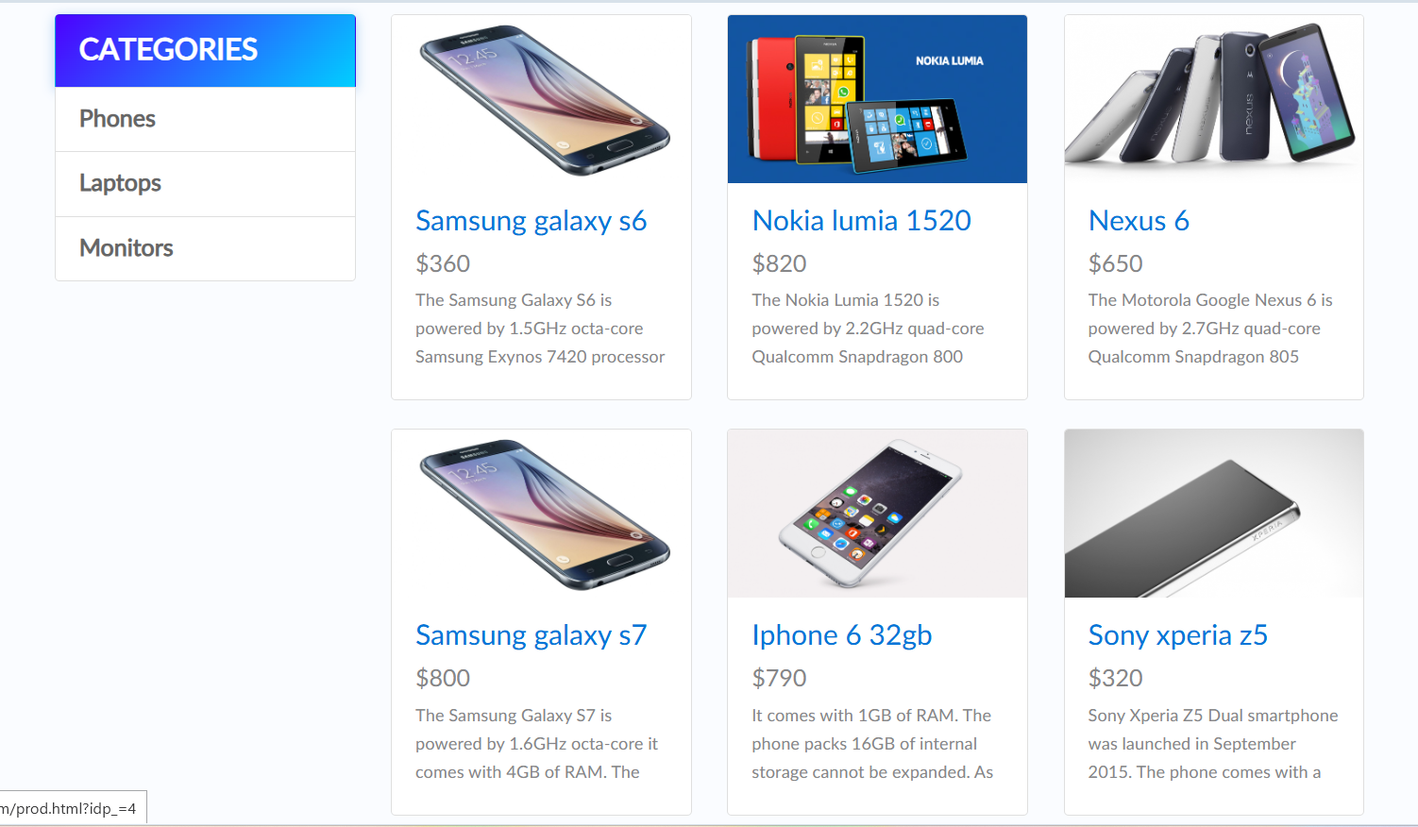
Bug_006_Outofstock.png

- TC_041-No confirmation alert after adding to cart
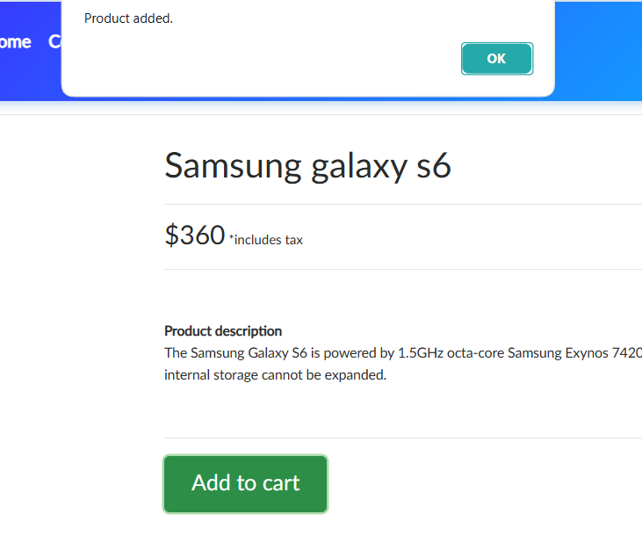
Bug_007_ConfirmationAlert.png
- TC_042-Category link not highlighted when selected
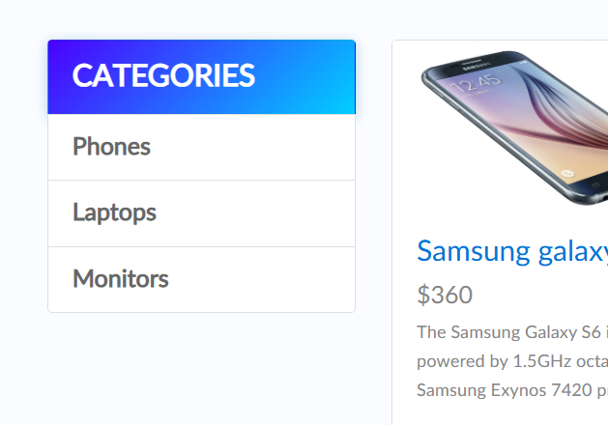
Bug_008_CategoryLink.png
- TC_043–050-Global Search bar is completely missing

Bug_009_SearBar.png

- TC_054-Quantity adjustment (+/-) not available)
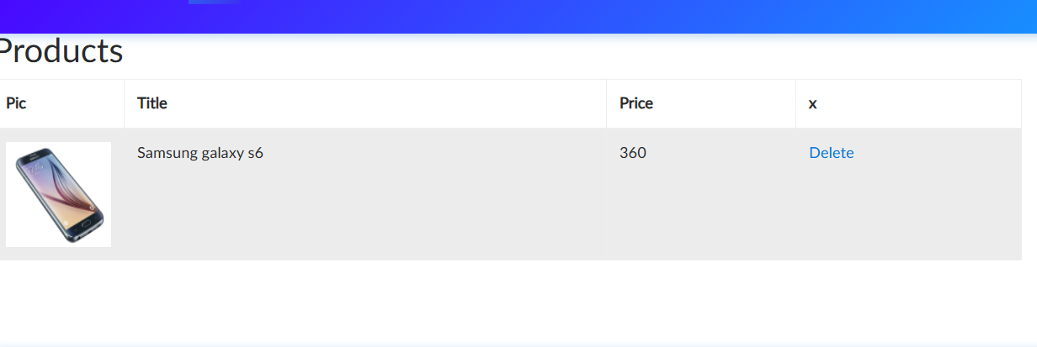
Bug_010_QuantityAdjustment.png
- TC_057-No "Continue Shopping" or Back button in cart
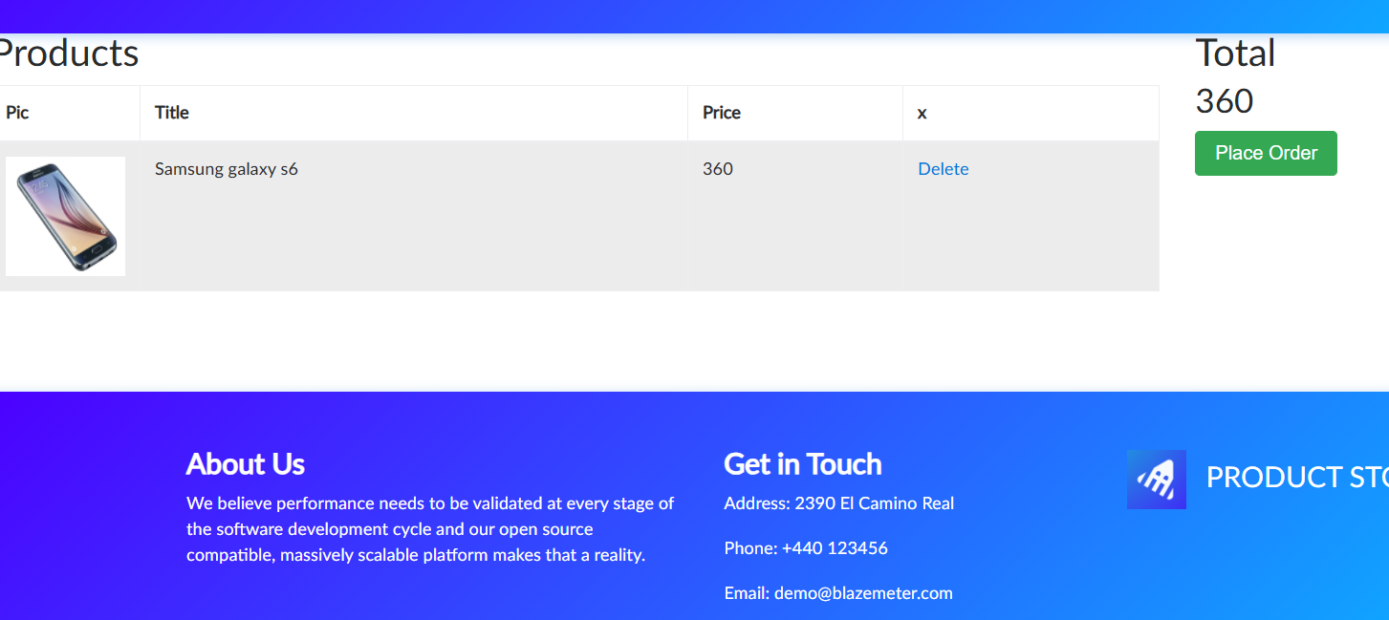
Bug_011_BackButton.png
- TC_066-Credit card >16 digits accepted
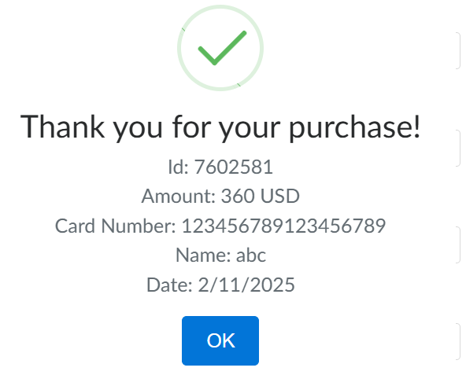
Bug_012_Cc>16.png

- TC_067-Credit card <16 digits accepted
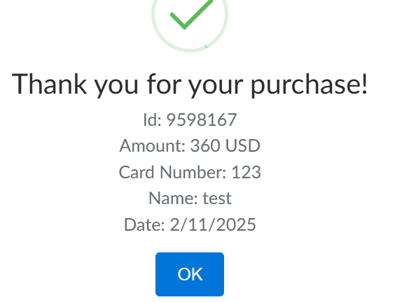
Bug_013_Cc<16.png
- TC_069-Purchase succeeds with invalid details
Bug_014_InvalidDetails.png

- TC_071-Invalid Month/Year accepted
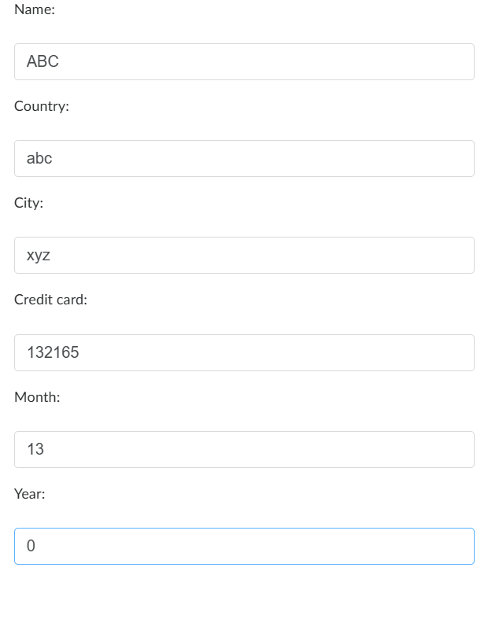
Bug_015_InvalidMonthYear.png
- TC_072-No placeholders in checkout form fields
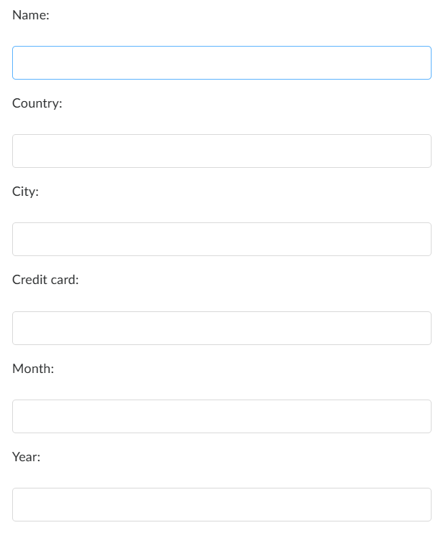
Bug_016_Placeholder.png

- TC_074-No "Save this card" or "Set default" checkbox
Bug_017_SetDefault.png
- TC_081-Message sent with invalid email
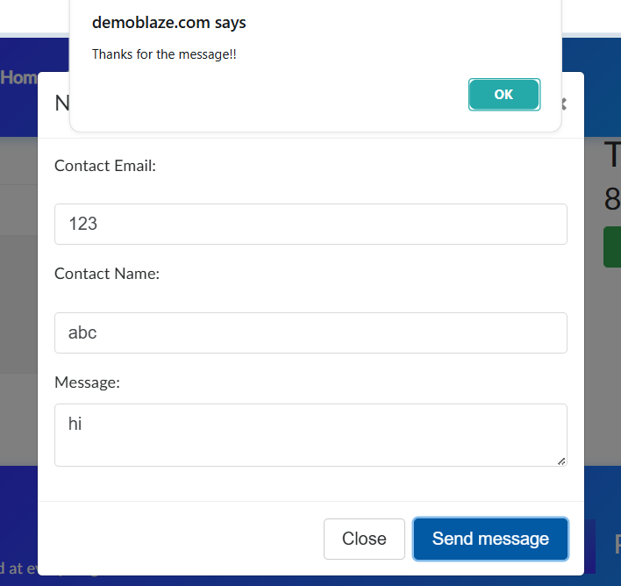
Bug_018_Message.png

- TC_082-Message sent without email/name
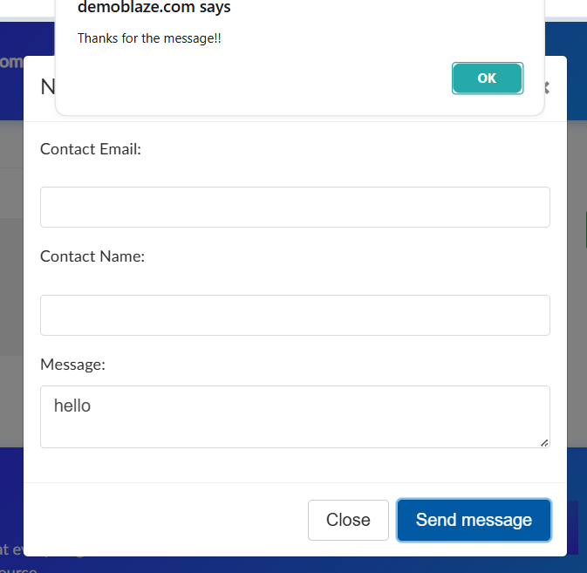
Bug_019_NoEmailMessage.png

